Module 5 Assignment
Data Modification Problem2
I have used Oracle and Sql Developer Client.
- Modification Statement
INSERT INTO Location(LocNo,FacNo,LocName)
VALUES ('L107','F104','Door');
- Before (7 rows)
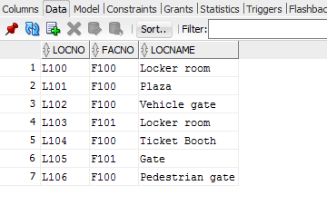
- Inserted
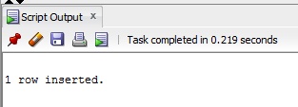
- After(8 rows)
